**Python Assignment 2**

**1.What are the two values of the Boolean data type? How do you write them?**

The two values of the Boolean data type are ***True*** and ***False.***

We write them are **True** and **False.**

**2. What are the three different types of Boolean operators?**

The result of the below three operators returns a Boolean value, meaning either **True** or **False**.

1. Python Comparison Operators (**==, !=, >, <, >=, <=** )
2. Python Logical Operators (**and, or, not**)
3. Python identity Operator **(is , is not**)

**3. Make a list of each Boolean operator's truth tables (i.e. every possible combination of Boolean values for the operator and what it evaluate ).**

|  |  |  |
| --- | --- | --- |
| **Operator A** | **Operator B** | **Logical AND result** |
| TRUE | TRUE | TRUE |
| TRUE | FALSE | FALSE |
| FALSE | TRUE | FALSE |
| FALSE | FALSE | FALSE |

|  |  |  |
| --- | --- | --- |
| **Operator A** | **Operator B** | **Logical OR Result** |
| TRUE | TRUE | TRUE |
| TRUE | FALSE | TRUE |
| FALSE | TRUE | TRUE |
| FALSE | FALSE | FALSE |

|  |  |
| --- | --- |
| **Operator A** | **Logical NOT Result** |
| TRUE | FALSE |
| FALSE | TRUE |

**4. What are the values of the following expressions?**

**(5 > 4) and (3 == 5)** = true and false = False

**not (5 > 4)** = not(true) = False

**(5 > 4) or (3 == 5)** = true or false = True

**not ((5 > 4) or (3 == 5))** = not(true) = False

**(True and True) and (True == False)** = true and false = False

**(not False) or (not True)** = true or false = True

**5. What are the six comparison operators?**

Comparison operators are used to compare two values. There are 6 comparison operators. Below are those 6 operators

|  |  |  |
| --- | --- | --- |
| **Operator** | **Name** | **Example** |
| == | Equal | x == y |
| != | Not equal | x != y |
| > | Greater than | x > y |
| < | Less than | x < y |
| >= | Greater than or equal to | x >= y |
| <= | Less than or equal to | x <= y |

**6. How do you tell the difference between the equal to and assignment operators? Describe a condition and when you would use one.**

Equal to is (==) and Assignment operator is (=).

Equal to operator (==) is used to compare two values, if they are equal or not.

Like 4 == 5

Assignment operator (=) is used to assign value to variable:

Like x = 5

**7. Identify the three blocks in this code:**

1. **spam = 0**
2. **if spam == 10:**
3. **print('eggs')**
4. **if spam > 5:**
5. **print('bacon')**
6. **else:**
7. **print('ham')**
8. **print('spam')**
9. **print('spam')**

1. Normal code block: line 1, 8 and 9

2. if block: from line 2 to 3

3. if-else block: from line 4 to 7

**8. Write code that prints Hello if 1 is stored in spam, prints Howdy if 2 is stored in spam, and prints Greetings! if anything else is stored in spam.**

spam = int(input('Enter a number :'))

if spam == 1:

    print("Hello")

elif spam == 2:

    print("Howdy")

else:

    print("Greetings!")

**9.If your programme is stuck in an endless loop, what keys you’ll press?**

Ctrl + c

**10. How can you tell the difference between break and continue?**

**Break**: A break statement in Python alters the flow of a loop by terminating it once a specified condition is met.

**Continue**: The continue statement in Python is used to skip the remaining code inside a loop for the current iteration only.

**Use of Break statement in a loop**

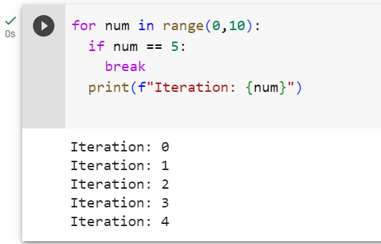

**Use of Continue statement in a loop**

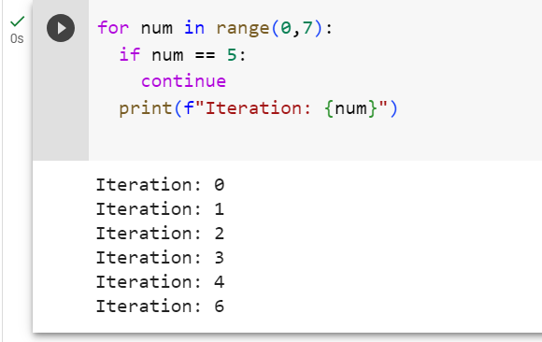

**11. In a for loop, what is the difference between range(10), range(0, 10), and range(0, 10, 1)?**

There is no difference between all these 3 range statements. All 3 will let a for loop iterate 10 times

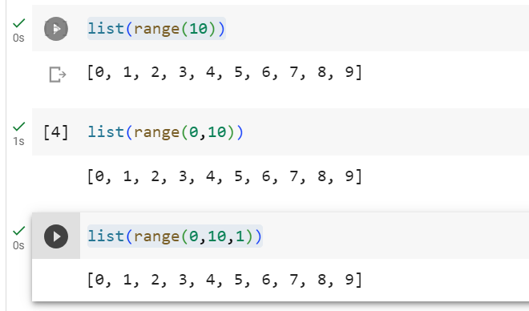

**12. Write a short program that prints the numbers 1 to 10 using a for loop. Then write an equivalent program that prints the numbers 1 to 10 using a while loop.**

for i in range(1,11):

    print(i)

i = 1

while i < 11:

    print(i)

    i += 1

**13. If you had a function named bacon() inside a module named spam, how would you call it after importing spam?**

import spam

spam.bacon()